Lab Objective

Learn how to Back Up System State

**Lab Procedures**

# Installing Windows Server Backup

**1.** Log in to Server01 as the **Contoso\administrator** using the password of **Password01** and **restart** the Virtual Machine. When Server01 restarts, log in as **Contoso\administrator** using the password of **Password01**. The Server Manager console opens.

**2.** On Server Manager, click Manage and click Add Roles and Features.

**3.** When the Add Roles and Features Wizard starts, click Next.

**4.** On the Select installation type page, click Next.

**5.** On the Select destination server page, click Next.

**6.** On the Select server roles page, click Next.

**7.** On the Select features page, click to select the Windows Server Backup and click Next.

**8.** On the Confirm installation selections page, click Install.

**9.** When the installation is complete, click Close.

# Performing a Back Up of the System State

1. Log in to RWDC01 as the **Contoso\Administrator** user account. The Server Manager console opens.
2. On RWDC01, open File Explorer and create a **C:\BAK** folder.
3. Right-click the BAK folder and click Properties.
4. When the Properties dialog box opens, click the Sharing tab.
5. Click Advanced Sharing.
6. When the Advanced Sharing dialog box opens, click Share this folder. Click Permissions. Click to select the Allow Change permission for Everyone. Click OK to close the Permissions for BAK dialog box. Click OK to close the Advanced Sharing dialog box.

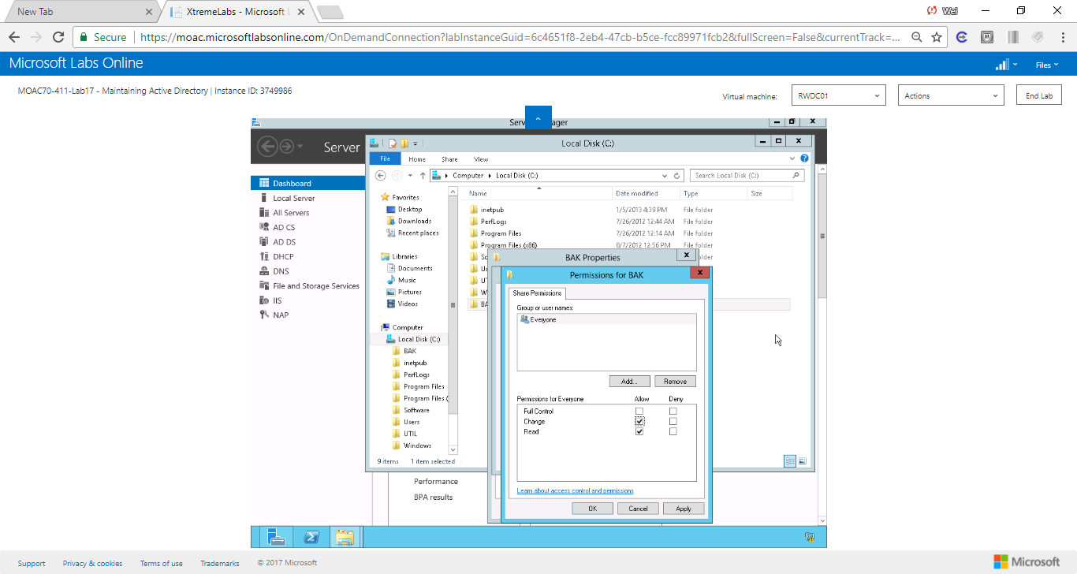

Figure Allow change permission to everyone

1. Click Close to close the Properties dialog box.
2. Restart Server01 and Log in as the **Contoso\administrator** user account, using the password of **Password01**.
3. On Server Manager, click Tools > Windows Server Backup. The Windows Server Backup console opens.
4. Click Local Backup in the left pane.
5. Under Actions, click Backup Once.
6. When the Backup Once Wizard starts, click Different Options and click Next.
7. On the Select Backup Configuration page, click Custom and click Next.
8. On the Select Items for Backup page, click Add Items. The Select Items dialog box opens as shown in Figure 17-1.

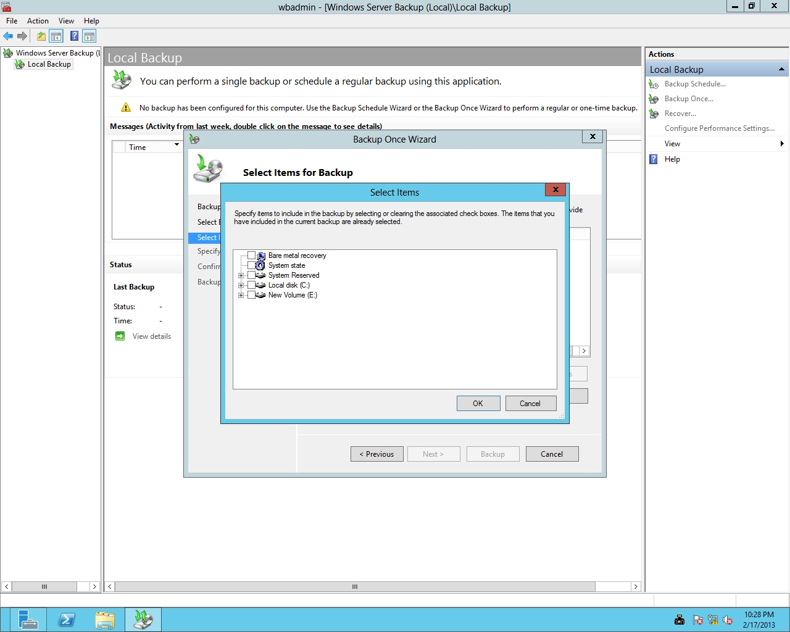

Figure 17-1

Selecting items for backup

1. Select System state and click OK.
2. On the Select Items for Backup page, click Next.
3. On the Specify Destination Type page, select Remote shared folder. Click Next.
4. On the Specify Remote Folder page, type **\\RWDC01\BAK** and click Next.

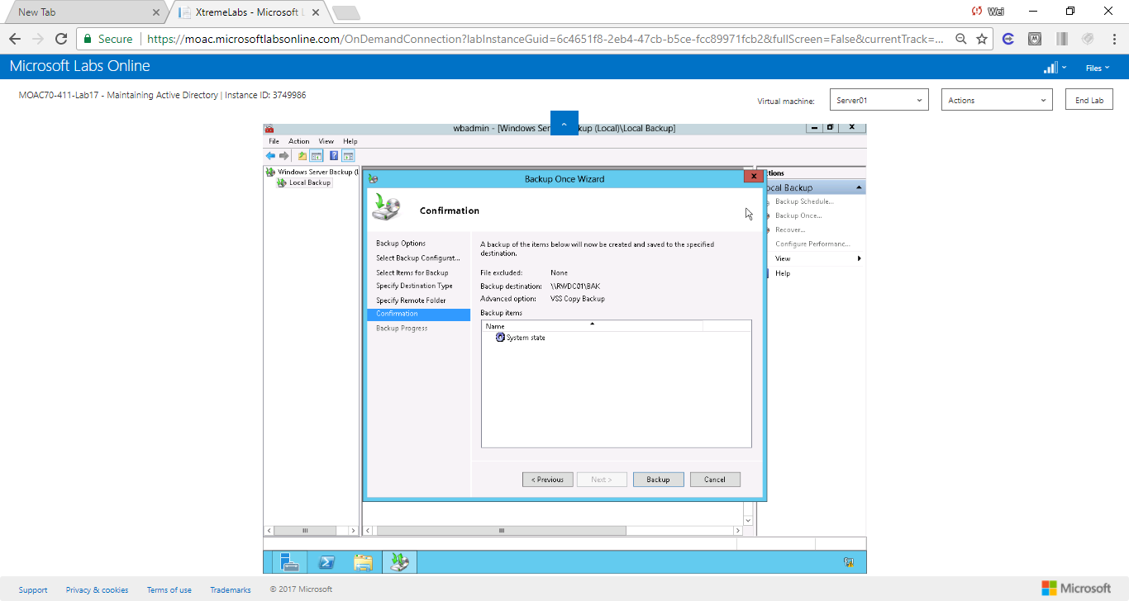

Figure . Screenshot of backup confirmation page

1. On the Confirmation page, click Backup. The backups will take a few minutes.
2. Click Close.

End of exercise.

**Lab Summary**

As a system administrator, it is important to have good backups. During this exercise, I used Windows Server Backup to back up the system state of Server01, which includes the Active Directory. Backups is a good method for disaster recovery. The entire lab took me about 20 minutes to complete.